**Fruit Ninja project report**

**description of the design:**

**The Main class of the game object is name GameObject and that class extends ImageView class.**

**Any game object is actually an image so every game object class extends from GameObject class.**

**FallingObjects class extends from GameObject, and all the rest classes of fruits bombs half fruits extends from FallingObjects class.**

**Fruit juice effects also extends from GameObject class.**

**ClassicGame class and ArcadeGame class extends from GamePlay class.**

**These is the main classes of the project.**

**class diagram:**

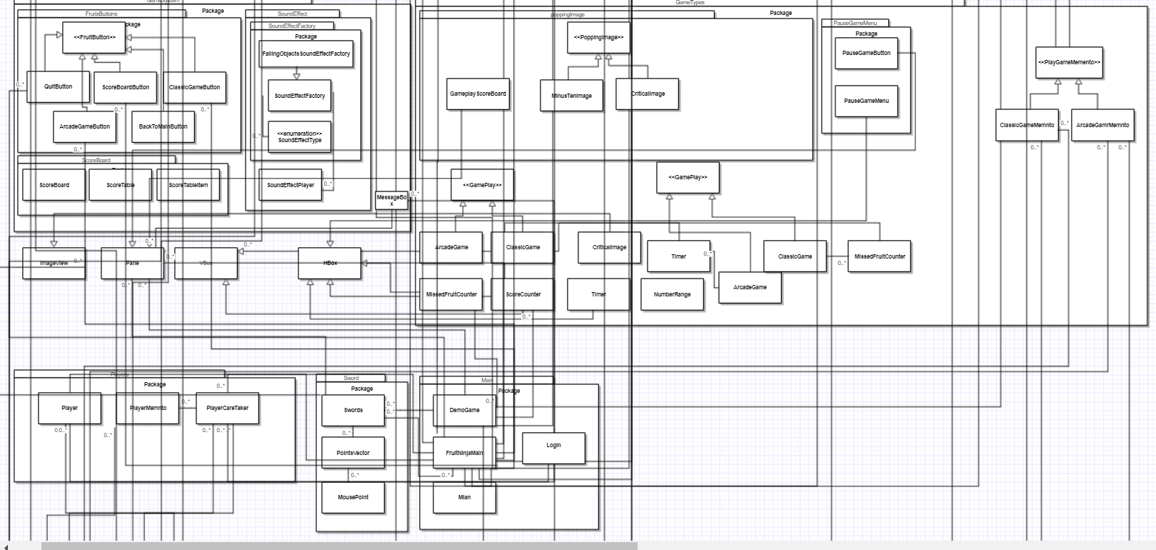

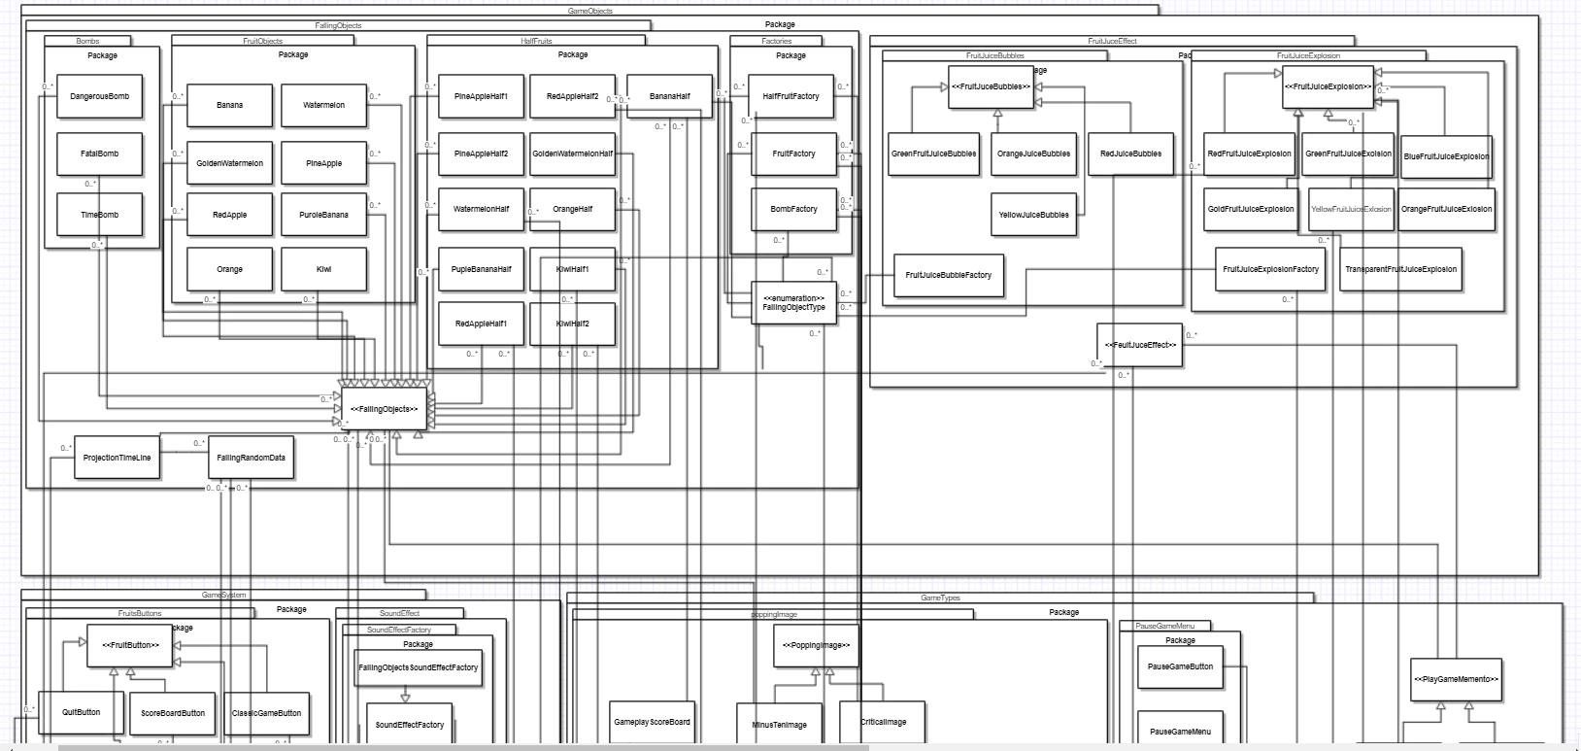

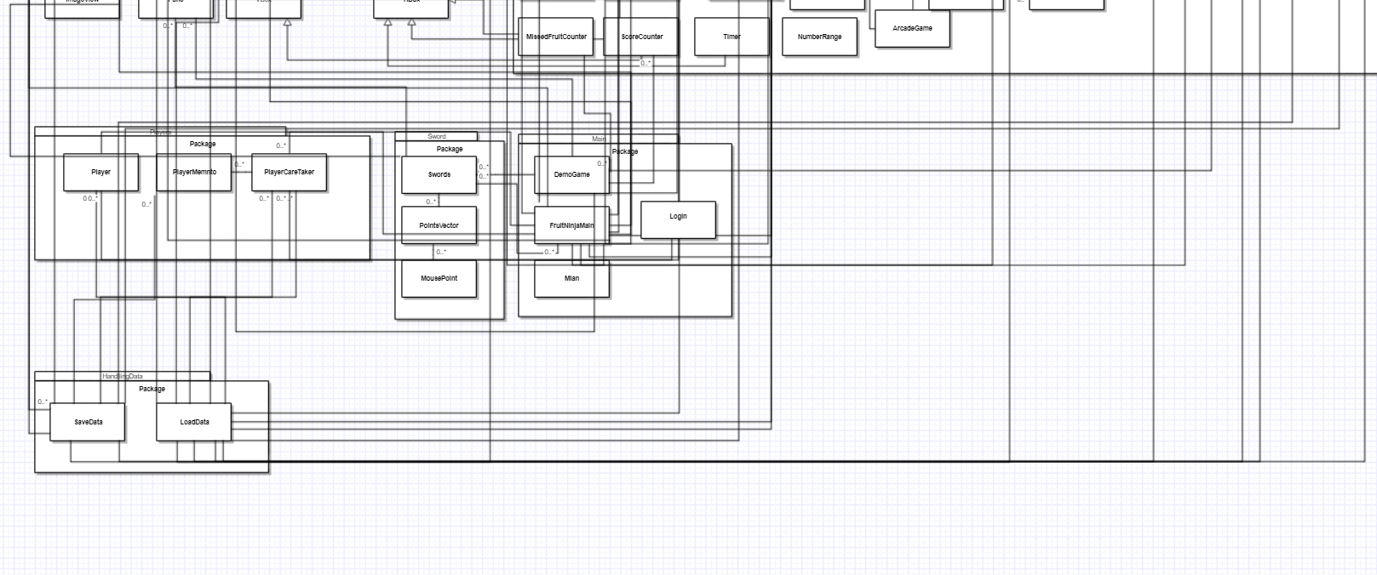

**Sequence diagram:**

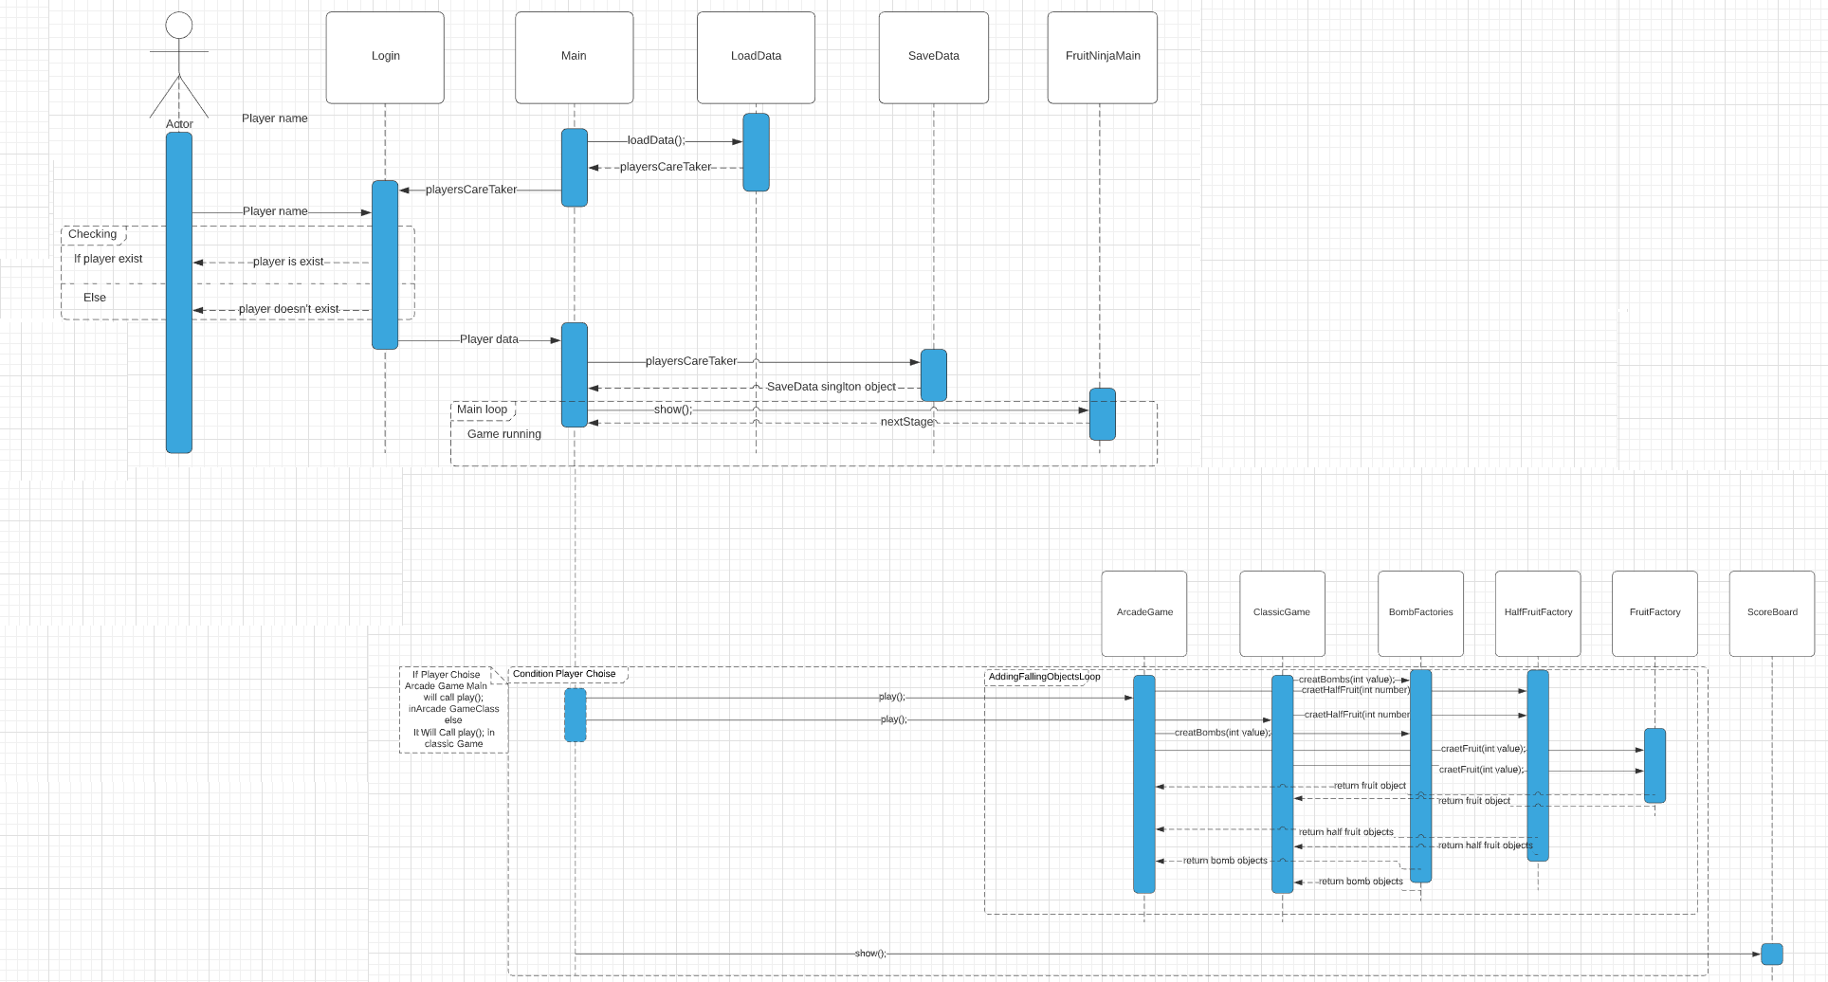

**Design patterns used in the project:**

1. **Singleton responsibility: used in save to send data from player caretaker only once in the game.**
2. **Factories: fruit factory, bomb factory, half fruit factory to generate random integers of fruit, bomb, half fruit in random falling objects. Sound factory: to easy have sound without writing its path. Explosions factory: to return explosion of certain fruit.**
3. **Mementos: to store player data and game data.**
4. **Decorator: it is used in score board to view scores of players**
5. **MVC is used in the project.**

**Snapshots of the GUI:**

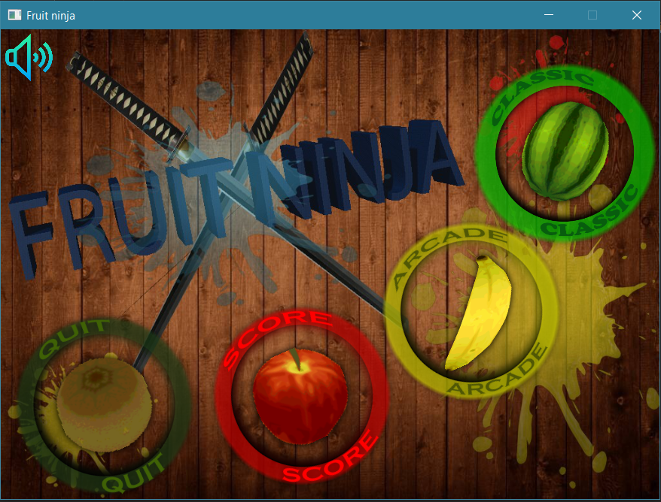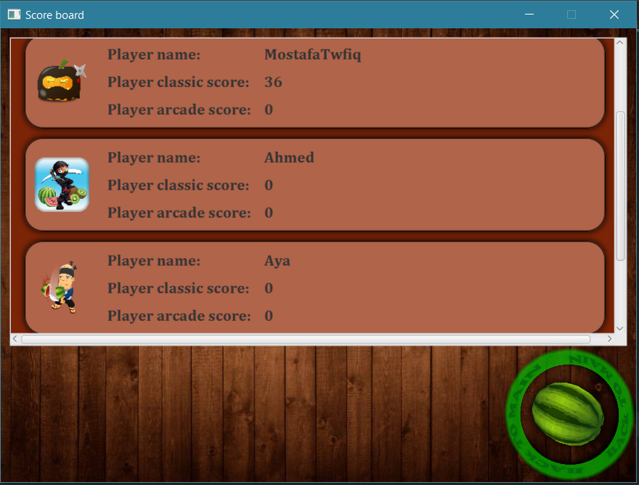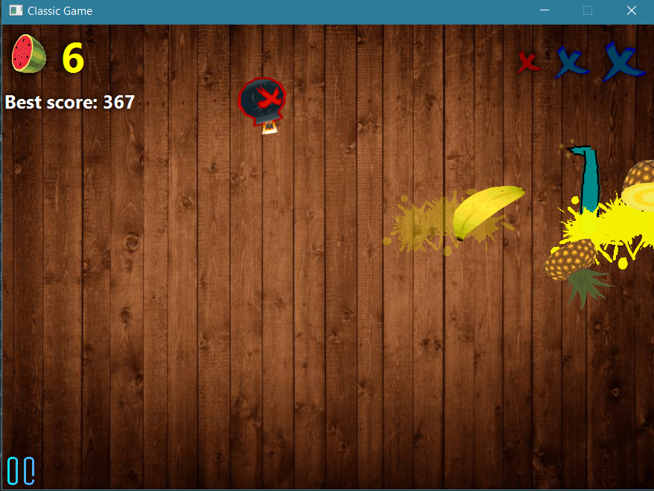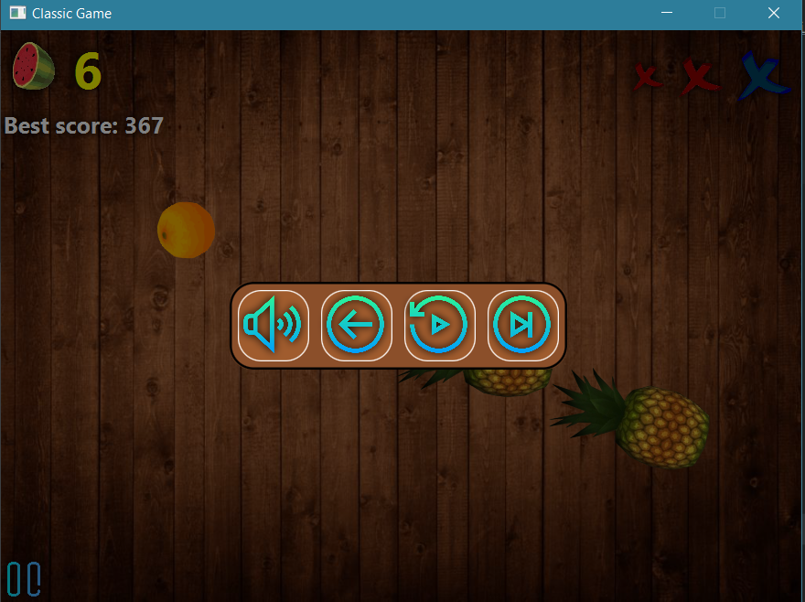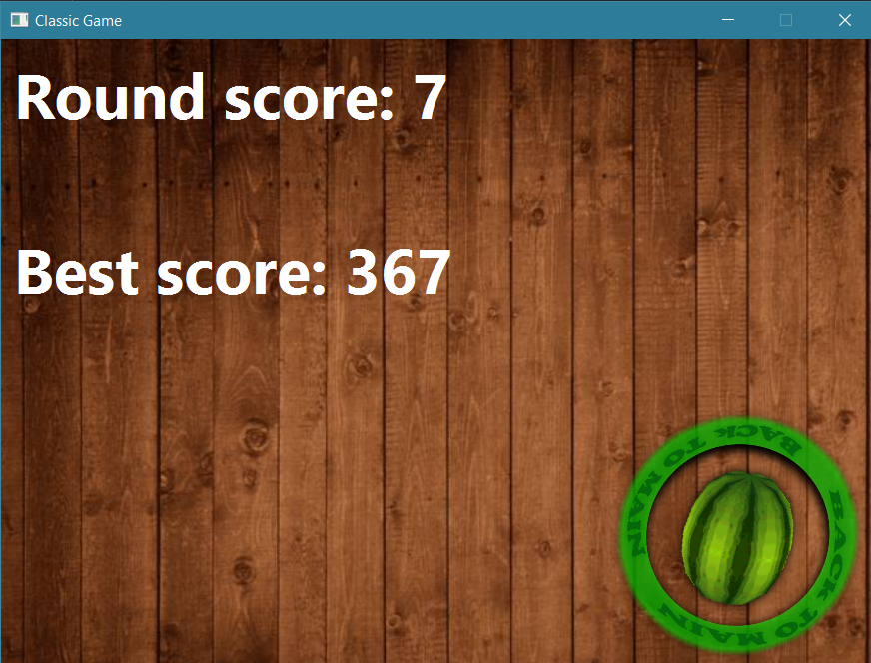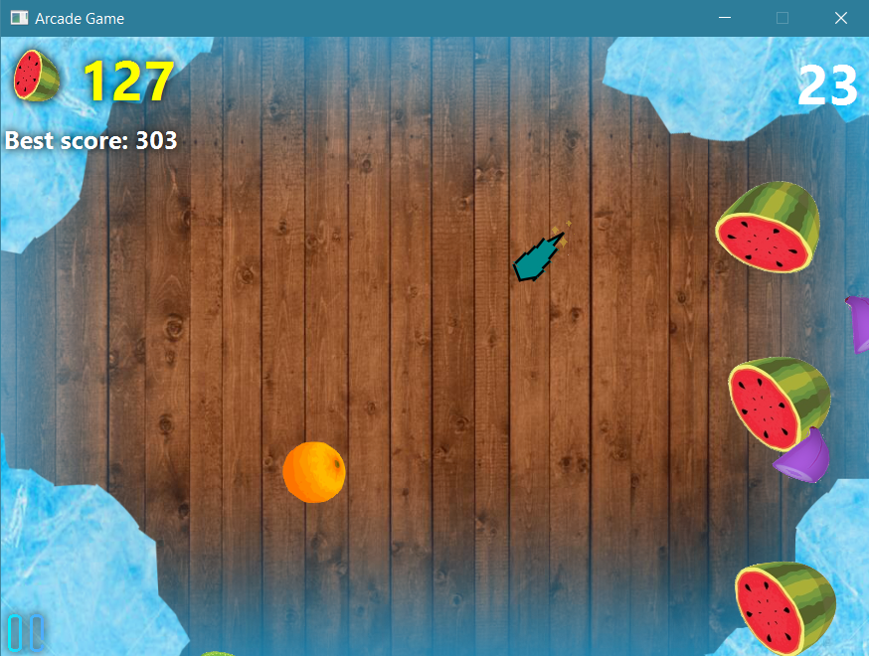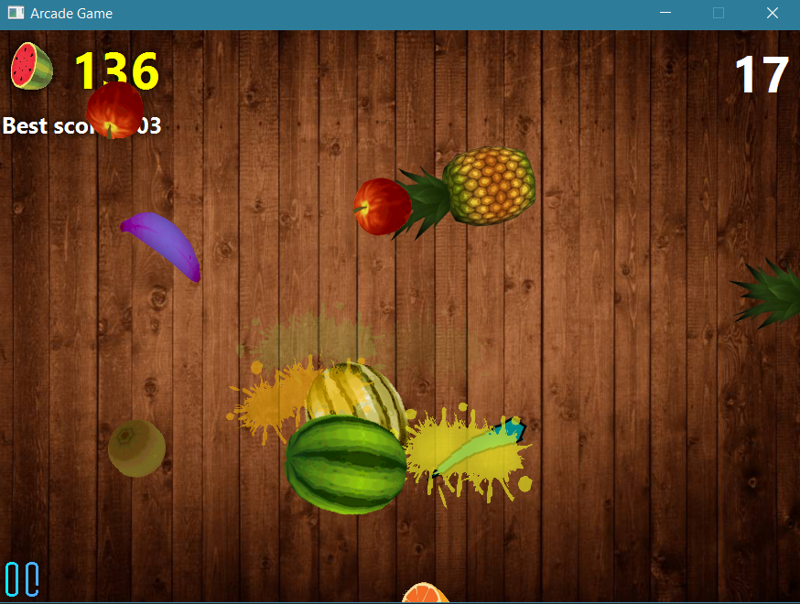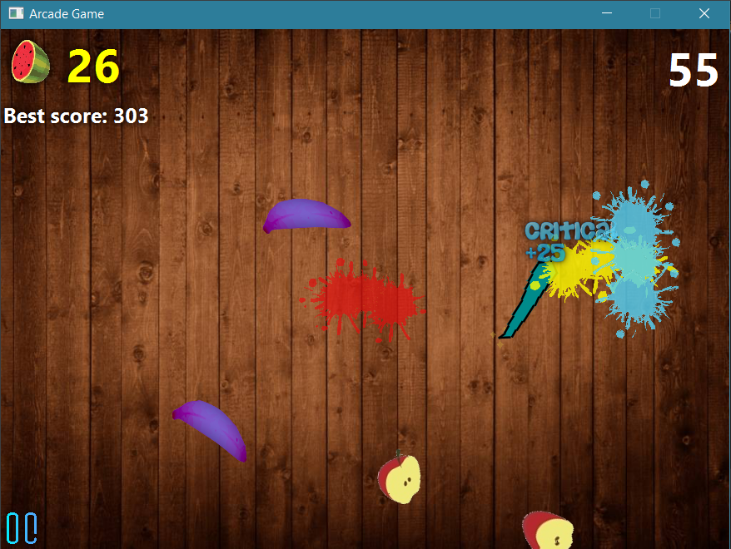

**User guide:**

**-At first, a window will appears to the player to login in if the player had signed up before (has a name in the game), or the player can Add a new player.**

**-Secondly, a window will appears to the player after logging in, it contains 4 options.**

**The first option is to start a classic game, the main idea of this mode that some fruits will be thrown throw the screen and the player has 3 lives only, lives will decrease by 1 if a fruit fall without being sliced, or slicing a dangerous bomb (blue bomb). If the player sliced a fatal bomb (red bomb) he/she will lose the game immediately.**

**The second option is to start an arcade game, the main idea of this mode that the player has one minute to slice as much as he can of fruits, Also there is two types of special fruits, the first one is a golden watermelon that if the player sliced it the rate of the thrown fruits in the game will increase, and the second type is a purple banana that if the player sliced it the motion of the game will be frozen.**

**There is a special type of slicing, a critical slice it will increase the player score by 25 points.**

**There are 3 stages(Levels) of difficulty, the first level when player score is less than 100 point, in this level the rate and speed fruits will be normal. The second level when player score is between 100 and 200 the number of bombs, rate and speed of fruits will increase and game will start to be harder. The third level when the player’s score is more than 300 the speed and number of fruits increase much more than the second level.**

**The player will get an extra life every new difficulty stage.**

**The game will end for 2 reasons, if the player loses all his lives, and the second reason if the player slices a fatal bomb.**

**The third option is to view the scoreboard that contains the score of each player (his name and his best score arranging in descending order)**

**-Finally, when player wants to exit the game he should slice the quit fruit (kiwi fruit).**